**Practical No-7**

**step1-**

**table-**

create table library(

bno number(5),

bname varchar2(20),

author varchar2(20),

allowed_days number(5)

);

-------------------------------------------

insert into library values(1,'spm','ram',5);

insert into library values(1,'cns','sham',10);

insert into library values(1,'dbms','gauri',8);

insert into library values(1,'toc','arya',7);

insert into library values(1,'mp','deep',18);

----------------------

select * from library;

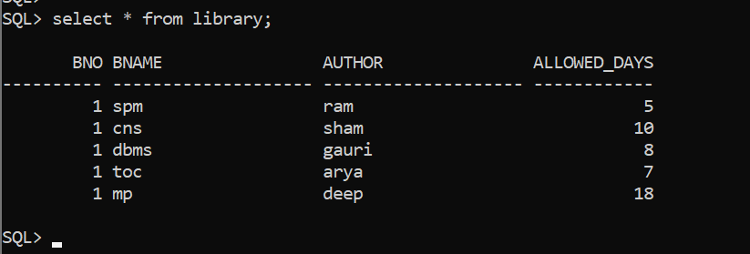

-------------------------------------------

**step 2-**

**table-**

create table library_audit(

bno number(5),

old_all_days number(5),

new_all_days number(5)

);

-----------------

select * from library_audit;

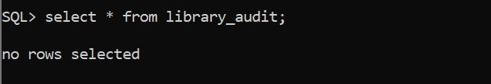

-------------------------------------------

set serveroutput on

-----------------------------------------

**step 3-**

**trigger-**

create or replace trigger Sample

before update or delete on library

for each row

begin

insert into library_audit values(:new.bno,:old.allowed_days,:new.allowed_days);

end;

/

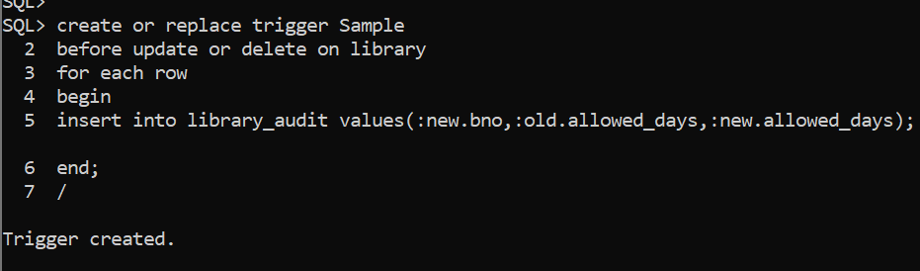

------------------------------------------

**step 4-**

update library set allowed_days = 15 where bno=1;

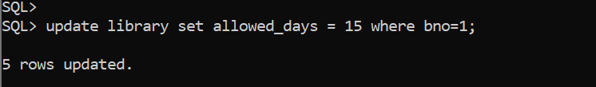

------------------------------------------

**step 5-**

select * from library_audit;



